Lakedell Agricultural Society

41st Annual Country Fair

Bench Show Booklet



Artwork By:

Celyn Rabbit ~ Grade 4

Lakedell School

# **COVER ART**

**The Lakedell Agricultural Society**

**held a drawing contest for students**

**Grades 1 to 6 from Lakedell, Falun and Pipestone Schools seeking a design for the 2017 Bench Show Booklet. The two winning works are featured on the front and back covers.**

**All entries will be displayed in the curling rink during the fair. Thank you to all students who submitted pictures. A huge Congratulations to Celyn Rabbit from Lakedell School and to Emersyn Tabler from Falun School for the winning artwork.**

**For any questions concerning our Bench Show or the Fair, feel free to contact the Office:**



**Lakedell Ag. Society**

**Box 166, RR 2**

**Westerose AB T0C 2V0**

**Phone: 780 - 586 - 2505**

**Email: lakedellag@xplornet.com**

**Contents**

**COVER ART** 2

**WELCOME** 3

**RULES & REGULATIONS** 4

**SECTION A – HANDICRAFT & NEEDLEWORK** **Error! Bookmark not defined.**

**SECTION B – QUILTING & SEWING** 5

**SECTION C - CRAFTS** 7

**SECTION D – BAKING** 8

**SECTION E – PRESERVED FRUIT, VEGETABLES & WINE** 9

Section F-

**SECTION G – FLOWERS & HOUSEPLANTS** 11

**SECTION H – ART & PHOTOGRAPHY** 12

**SECTION I – JUNIORS** 13

**DIRECTIONS** 15

**Welcome**

On behalf of the LAS Board and my wonderful group of volunteers, welcome to the 41st Annual Lakedell Country Fair Bench Show. Farm communities have a long tradition of gathering in the fall to celebrate another year’s harvest. The Bench Show at Lakedell features amazing artwork and photography, stunning floral displays, a wide variety of baking and preserves and beautiful needle crafts. The junior section is always filled with innovative and interesting entries. We have high point prizes in each age category as well as trophies for the most entries. So if you spent the long winter knitting, love baking, have a smashing garden or have talents in any of our sections, bring your work to the Lakedell Fair. Please take a moment to review the rules page to make sure your entry qualifies. See you on the September Long Weekend.

Eileen Burkholder

Bench Show Coordinator

# **RULES & REGULATIONS**

1. Entry tags will be available on Entry Day, or can be obtained ahead of time at the Lakedell Agricultural Office. Regular office hours are Tuesdays, Wednesdays and Thursdays from 9am to 4pm. All entries must be tagged. Entrants must fill in their own tags, including Section, Class No. and description of exhibit. In Exhibitor No. Box, please mark your division, as per High Point Trophies Award.
2. All exhibits must be the bona-fide work of the exhibitor and must not have been previously entered in the Lakedell Fair, with the exception of houseplants. Soiled, unfinished or worn out articles will not be accepted. Only one entry, per class number, per exhibitor. Enter the exact number called for in each class, more or less will disqualify the entry. Juniors may enter in the adult class if no class is available in their section.
3. Entries are judged using the Danish System. Please see page 7 for more details. All judges’ decisions are final.
4. Entries will only be **accepted on Friday, September 2nd from 2pm until 6pm**. Judging will take place starting at 6:30pm.
5. The Bench Show “Most Entries Trophy” will be awarded by the Lakedell Agricultural Society. It will remain at Lakedell Centre and a keeper trophy or prize will be awarded to the winner.
6. High Point Prizes will be awarded in the following divisions: Men’s Senior (65 plus), Ladies Senior (65 plus), Adult Men’s, Adult Ladies, Teen Boys 13-17, Teen Girls 13-17, Boys 7-12, Girls 7-12, Boys under 7 years, Girls under 7 years.
7. Exhibits will be open for public viewing from 9:00 am to 4:30 pm on Fair Day, September 3th, 2016. Award are presented at 4:00 pm.
8. All exhibitors are asked to **remove their exhibits between 4:30pm and 5:30pm, September 3th, 2016.**
9. **Lakedell Agricultural Society will not be responsible for loss or breakage of any exhibit from any cause whatsoever, but the greatest care will be exercised.**

# **SECTION A – HANDICRAFT & NEEDLEWORK**

* All articles must be clean and pressed.
* Articles must be finished and ready to use.
* Articles will be judged on workmanship only.
* Avoid entering garments that look worn.

**KNITTING**

100. Slippers, Mittens or Socks

101. Baby Layette

102. Men’s or Ladies Cardigan Sweater

103. Men’s or Ladies Pullover Sweater

104. Children’s Cardigan or Pullover

105. Afghan or Bedspread

106. Cushion Cover

107. Bulky Knitting

108. Doll Clothing

109. Any article - novelty

110. Any article - practical

111. Any article not included above.

**CROCHET**

112. Doilies, flat up to 12”

113. Doilies, flat 12”-24”

114. Tablecloth or Bedspread (thread)

115. Afghan

116. Cushion Cover

117. Shawl

118. Three-piece baby layette

119. Rug

120. Any other article not included above (thread or yard)

**NEEDLECRAFT**

121. Hardanger, any article

122. Candle-wicking, any article

123. Crewel, any article

124. Petite-point, any article

125. Needlepoint, any article

126. Needlepoint - done on plastic canvas

127. Cross Stitch, any article

128. Needlecraft, any of the above (Christmas Theme)

129. Embroidery, Bunka - dress, scarf, pillow case or cushion

130. Embroidery - dress, scarf, pillow case

or cushion.

131. Embroidery, Silk Ribbon or Brazilian

132. Stitchery, any article not included above.

**MACHINE EMBROIDERY**

133. Tablecloth

134. Table Runner

135. Napkins - set of 4

136. Tea Towels - pair

137. Tote Bag

138. Bookmark

139. Single Article of Clothing

140. Any other article not included above

**OTHER**

141. Beadwork - any article

142. Weaving, off loom primitive (not rugs)

143. Weaving, loom

144. Homespun Yarn - 2 oz.

145. Rug – hooked, new material

146. Rug - any method, new material

147. Rug - any method, old material

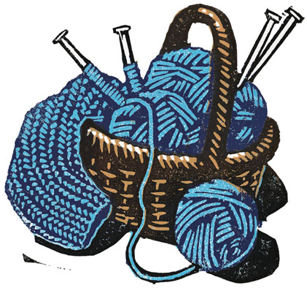148. Rug - Latch Hook

# **SECTION B – QUILTING & SEWING**

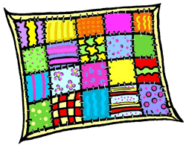

**QUILTING**

200. Patchwork Quilt - hand quilted

201. Patchwork Quilt - machine quilted

202. Comforter, hand tied

203. Wall Hanging, quilted

204. Jacket or Vest, quilted

205. Place Mats or Pot Holders, quilted

206. Quillo

207. Quilt Block

208. Rag Quilt

209. Any other article not included above

**SEWING**

210. Blouse - ladies or child’s

211. Slacks or Shorts - ladies, men’s or children’s

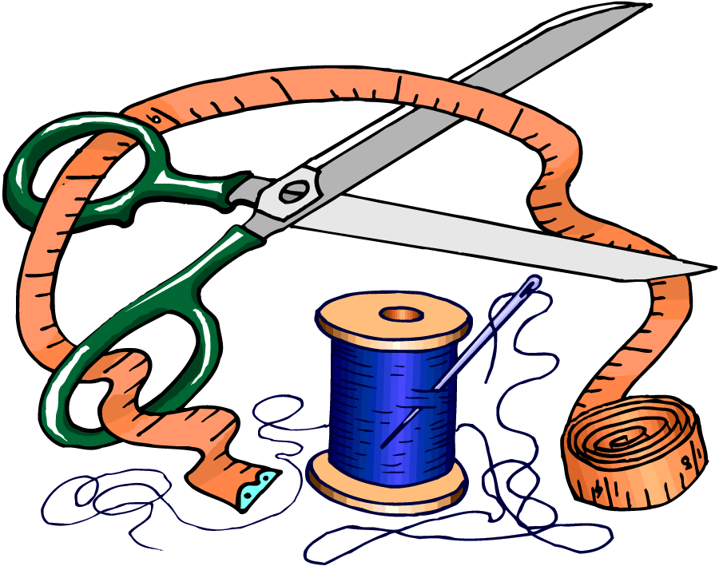212. Shirt - ladies, men’s or children’s

213. Casual Dress - ladies or children’s

214. Formal Dress - ladies or children’s

215. Jacket -ladies, men’s or children's

216. Western Wear - ladies, men’s or children's

217. Sportswear - ladies, men’s or children's

218. Sleep Wear - ladies, men’s or children's

219. Stretch sewing (ie: t-shirt, pants)

220. Adult Outfit - two or more pieces

221. Girl or Boy Outfit - two or more pieces

222. Cushion, any type

223. Mats, Potholders, Oven Mitts, Apron etc.

224. Recycled Items

225. Halloween Costume

226. Doll Clothes

227. Any article not included above

# **SECTION C - CRAFTS**

300. Valentine Craft

301. Easter Craft

302. Fall/Thanksgiving Craft

303. Halloween Craft

304. Christmas Craft

305. Wreath

306. Christmas Ornament, religious

307. Christmas Ornament, secular

308. Swag

309. Christmas Centerpiece

310. T-Shirt - decorated

311. Jewelry

312. Decorated Basket

313. Wall Hanging - Heat’N Bond

314. Wall Hanging - any other

315. Folk Art

316. Paper Tole

317. Silk Flower Arrangement

318. Doll - hand made

319. Pottery - any article

320. Ceramics - any article

321. Leather Craft -tooled

322. Leather Craft - soft

323. Woodwork - any large piece

324. Woodwork - carved

325. Woodwork - any large piece

326. Woodwork - birdhouse

327. Woodwork - any small piece

328. Greeting Card - rubber stamp

329. Dried Flower Arrangement

330. Weed Arrangement

331. Tole Painting

332. Decorated Picture Frame

333. Soap, hand made

334. Scrapbooking - computer

335. Scrapbooking - hand made

336. Any other article not included above

**Judging**

All entries are judged using the Danish System where they are compared to a standard rather than to the other entries. For example, in the muffins section, you may see three red ribbons, no blue and one white. This simply indicates that three of the entries met all of the standard for muffins and one only met some. Occasionally, the judges will give an award of excellence to an outstanding entry.

Rosette – Meets all standards and shows excellent quality

Red – 8, 9, 10 points – 1st Place

Blue – 5, 6, 7 points – 2nd Place

White – 1, 2, 3, 4 points – 3rd Place

Pink – Honorable Mention

# **SECTION D – BAKING**

* No commercial mixes or fillings
* All entries should be displayed on paper plates suitable in size and wrapped in plastic twist tie bags or Ziploc bags.
* Name the recipe where possible.

400. Bread Machine - 1 loaf any type

401. White bread, yeast - 1 loaf

402. Brown bread, yeast - 1 loaf

403. Cheese bread, yeast - 1 loaf

404. Health bread, yeast - 1 loaf

405. Raisin bread, yeast - 1 loaf

406. Sweet bread, yeast - 1 loaf

407. White Dinner Buns, yeast - 3

408. Brown Dinner Buns, yeast – 3

409. Cinnamon buns, iced, yeast - 4

410. Cinnamon buns, un-iced, yeast - 4

411. Doughnuts, yeast - 3

412. Doughnuts, cake - 3

413. Baking Powder Biscuits - 3

414. Fruit Bread - 1 loaf

415. Muffins, bran - 3

416. Muffins, carrot - 3

417. Muffins, health - 3

418. Cake, Angel Food (from scratch)

419. Cake, Carrot (un-iced)

420. Cake, White Batter 8x8

421. Cake, Chocolate

422. Cake, Sponge

423. Cake, Plain Chiffon

424. Cake, Other Chiffon

425. Apple Pie (double crust)

426. Raisin Pie (double crust)

427. Rhubarb Pie (double crust)

428. Saskatoon Berry Pie (double crust)

429. Lemon Meringue Pie (bottom pastry)

430. Cream Pie (bottom pastry)

431. Cookies, Shortbread - 6

432. Cookies, Peanut Butter - 6

433. Cookies, Chocolate Chip - 6

434. Cookies, Sugar (rolled, cutter) - 6

435. Cookies, Oatmeal - 6

436. Butter Tarts - 3 squares

437. Brownies - 3 squares

438. Fudge Candy - 3 Pieces

439. Peanut Brittle – 3 Pieces

440. Microwave Baking, whole cake

441. Microwave Baking, squares - 4

442. Cupcakes, white

443. Cupcakes, chocolate

444. Cupcakes, decorated

445. Special Occasion Cake (judged on decoration only, could be done on Styrofoam etc.)

446. Any other baking not included above.

# **SECTION E – PRESERVED FRUIT, VEGETABLES & WINE**

* All jars will be opened.
* Any preserves not properly sealed will be disqualified.
* Jars should be pint or quart size.
* Standard canning jars with snap lids are preferred.
* Label jars - not lids.
* Labels should indicate date and contents.
* Commercial pectin may be used in jams & jellies.

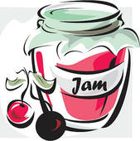500. Fruit Jam - 1 jar, labeled

501. Fruit Jelly - 1 jar, labeled

502. Freezer Jam - 1 jar, labeled

503. Marmalade - 1 jar, labeled

504. Pickles, Dill - 1 jar

505. Pickles, Bread and Butter - 1 jar

506. Pickles, Beet - 1 jar

507. Pickles, Sweet Mixed – 1 jar

508. Pickles, Mustard - 1 jar

509. Canned fruit, purchased - 1 jar, labeled

510. Canned fruit, home grown – 1 jar, labeled

511. Canned Fruit, wild – 1 jar labeled

512. Canned Tomatoes - 1 jar

513. Canned Harvard Beets - 1 jar

514. Sauerkraut - 1 jar

515. Chutney - 1 jar

516. Relish - 1 jar

517. Antipasto - 1 jar

518. Salsa

519. Any other item not included above

520. Wine, red - 1 bottle labeled (from kit)

521. Wine, white - 1 bottle labeled (from kit)

522. Wine, red - 1 bottle labeled (from scratch)

523. Wine, white - 1 bottle labeled (from scratch)

**Thank You**

A huge thank you to the people who help make the bench show possible. The **volunteers** who set up and take down, take entries, arrange displays, cook for us and help the judges. The **judges** who take time out of their busy schedules to share their expertise with us.

# **SECTION F – FRESH VEGETABLES, FRUIT & FARM PRODUCTS**

* All entries should be clean, fresh and of standard size for the type.
* All entries should be free from insect damage and blemishes of any kind such as breaks, bruises, sunburn and dirt.
* All entries should be clean but not scrubbed.
* Root vegetables should have the tops trimmed to 1 cm above the crown.
* All entries should be displayed on paper plates suitable in size and wrapped in plastic twist tie bags or Ziploc bags.

**FRESH VEGETABLES**

600. Parsnips - 4

601. Carrots - 4 of one variety

602. Beets, round - 4

603. Beets, cylinder - 4

604. Cabbage, green - 1 head

605. Cabbage, red - 1 head

606. Cherry Tomatoes with stems - 6

607. Tomatoes, ripe - 4 with stems

608. Tomatoes, ripe greenhouse - 4 with stems

609. Tomatoes, green - 4 with stems

610. Onions, winter storing - plate of 4

611. Potatoes, red - plate of 4

612. Potatoes, white - plate of 4

613. Potatoes, Netted Gem - plate of 4

614. Cucumbers, slicing plate of 6

615. Cucumbers, pickling - plate of 6

616. Peas, 1 variety - 6 pods

617. Broad beans - 3 pods

618. Beans, green - 6 pods with stems

619. Beans, yellow - 6 pods with stems

620. Corn on the Cob - 2

621. Peppers Green - 2 with stems

622. Celery - 1 plant

623. Scarlet Runner Beans - 3 with stems

624. Purple Beans - 3 with stems

625. Pumpkin - 1 green or orange with stem

626. Zucchini - 1, 8-10 inches in length

627. Zucchini - 1 biggest zucchini class

628. Potato - 1 biggest potato class

629. Crab Apples - 6 with stems

630. Eating Apples - 3 fruits

631. Cooking Apples - 3 fruits

632. Strawberries, ripe - 6 with stems

633. Raspberries, ripe - 6 with stems

634. Currants - 4 clusters with stems

635. Plums - 4, with stems

636. Turnips, summer - 2

637. Turnips, winter - 1

638. Herb Collection - at least 4 kinds in separate jars of water (varieties labeled)

639. Vegetable Collection - at least 7 kinds (including potato)

640. Any other vegetable not included above

641. Any other fruit not included above

**FARM PRODUCE**

642. Cheese - any kind

643. Eggs - 1 dozen

644. Goat Products

645. Any other product not included above

**GRAINS, GRASSES, LEGUMES**

646. Sheaf of grain - any kind

647. Canola - 1 quart

648. Grain - 1 quart (last year’s harvest)

649. Hay (ie: alfalfa, clover) - 3lb. Plastic bag

650. Mixed Hay - 6 lb. plastic bag

651. Field peas - 1 quart

652. Any other not included above

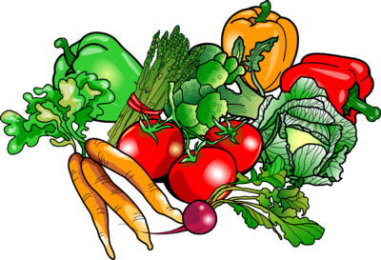

# **SECTION G – FLOWERS & HOUSEPLANTS**

* Classes that call for 1 stem or spike can be shown with leaves, buds, and flowers.
* Classes that call for blooms - only the flower is judged and should be displayed on a flat plate covered with foil with holes for stems (please include water).
* Roses should be shown with stem and leaves attached.
* House plants and planters are judged on plants not container, although container should be suitable.
* Name the variety where possible.

700. Aster - any variety, 4 blooms

701. Clematis - 2 blooms, any colour

702. Cornflower (Bachelor Button) - 6 blooms

703. Dahlia - 1 bloom under 5” with first set of leaves

704. Dahlia - 1 bloom over 5” with first set of leaves

705. Daisy, any variety - 6 stems

706. Gladiolus - 1 spike, any colour

707. Marigolds, over 3” - 4 blooms

708. Marigolds, under 3” - 4 blooms

709. Pansy or Viola, under 2” - 6 blooms

710. Pansy or Viola, over 2” - 6 blooms

711. Petunia, single plain - 4 blooms

712. Petunia, double - 4 blooms

713. Rose, Hybrid Tea - only long stem

714. Roses - one spray shrub variety

715. Rose Bowl - shown with foliage

716. Snapdragon - 3 spikes

717. Strawflower - 4 blossoms

718. Sunflower - in prime bloom, not seeded

719. Sweet Peas - 4 stems, one color

720. Sweet Peas - 12 stems, 4 colors, 3 of each

721. Zinnia - 3 Blooms

722. Corsage Fresh Flowers

723. Arrangement Garden Flowers - viewed one side

724. Arrangement Garden Flowers Center Piece - under 8 inches high

725. Arrangement Garden Flowers Center Piece - over 8 inches high

726. Green Trailing Plants

727. Flowering Trailing Plants

728. Begonia - Tuberous

729. Begonia - Fibrous

730. Cactus - Flowering

731. Cactus - Non-Flowering

732. Carnation

733. Geranium

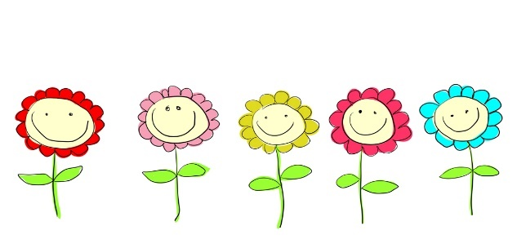734. Fuchsia

**PLANTERS**

736. Hanging Basket

737. Window Box

738. Planter Arrangement - 6-12” in diameter

739. Planter Arrangement - 12” and over in diameter

740. Vegetable Planter

741. Herb Planter

742. Mini Planter - under 6”

743. Unique Planter - judged on container

# **SECTION H – ART & PHOTOGRAPHY**

* Art should be mounted and ready to hang.
* Pictures done on paper if not framed should be mounted on stiff backing at least 1” longer than the picture.
* Photos should be print size only; panorama size prints are acceptable.
* All photos should be mounted on stiff white backing with 1/2” border.
* Enlarged photos are to be framed.

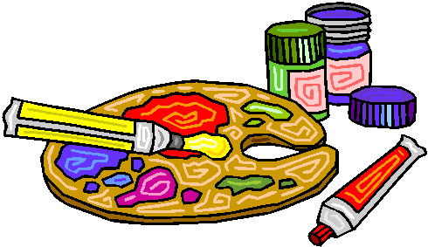ART

**Oils**

800. Birds

801. Flower

802. Animal Life

803. Still Life

804. Landscape

805. Other

**Acrylics**

806. Birds

807. Flowers

808. Animal Life

809. Still Life

810. Landscape

811. Portrait

812. Other

**Watercolours**

813. Birds

814. Flower

815. Animal Life

816. Still Life

817. Landscape

818. Portrait

819. Other

**Various Mediums**

820. Black and White Sketch - unframed

821. Pastel

822. Charcoal

823. Pencil

824. Ink

825. Other Medium

**PHOTOGRAPHY**

**Colour Snap Shot**

826. Animals

827. Birds

828. Flowers

829. Still

830. Scenic

831. Sports (action)

832. Humorous

833. Portrait

834. Night Photo

835. Generations

836. Story-telling Collage

837. Scrapbook

838. Other

**B&W Snap Shot**

839. Animals

840. Birds

841. Flowers

842. Still

843. Scenic

844. Sports (action)

845. Humorous

846. Portrait

847. Night Photo

848. Generations

849. Story-telling Collage

850. Other

**Enlarged (Framed)**

851. Animals

852. Birds

853. Flowers

854. Still

855. Scenic

856. Sports (action)

857. Humorous

858. Portrait

859. Night Photos

860. Generations

861. Other

# **SECTION I – JUNIORS**

* Two Age Categories:
  + 7 to 12 years
  + 6 years and under
* All junior entries are to follow the same guidelines as the adult entries.

**CRAFTS**

900. Valentine Craft

901. Easter Craft

902. Fall/Thanksgiving Craft

903. Halloween Craft

904. Christmas Craft

905. Christmas Ornament

906. Wreath

907. Fabric Painting

908. Wrapped Gift Box

909. Any Occasion Card

910. Computer Designed Card

911. Pressed Flowers, Leaves, Weeds

912. Recycled Article - paper

913. Recycled Article - plastic

914. Recycled Article - tin can

915. Bead Craft

916. Friendship Bracelet

917. Doll of any kind

918. Doll Clothes

919. Candle

920. Kite

921. Paper Craft

922. Wood Craft - large (ie: Bird house)

923. Wood Craft - small (ie: popsicle sticks)

924. Stuffed Toy - from kit

925. Stuffed Toy - original

926. Fridge Magnet

927. Collection

928. Scale model - kit

929. Scale model - hand made

930. Lego, Mechano, etc.

931. Craft project - from camp

932. Pottery - ceramic or clay

933. Craft made from Playdoh or Plasticine

934. Diorama or Scenic Display

935. Decorated Basket

936. Leather Craft - any type

937. Plastic Canvas

938. Pom-pom craft

939. Any other craft article

**ART**

940. Painting - water color

941. Painting - oil or acrylic

942. Picture - wax crayon

943. Picture - pencil crayon

944. Picture - felt marker

945. Picture - oil pastel

946. Pencil Sketch

947. Page from coloring book-any medium

948. Finger Painting

949. Print making - wood, potato, etc.

950. Collage

951. Creative Computer Design

952. Any other article

**PHOTOGRAPHY**

953. Pet

954. Family fun

955. Portrait

956. 4 or more photos that follow a theme or tell a story

957. Scrapbook

SEWING

958. Tote Bag

959. Vest

960. Sleepwear

961. Sportswear

962. Crazy Hat

963. Boxers

964. T-shirt

965. Kitchen Accessory

966. Recycled Article

967. Craft - sewn from a kit

968. Craft - sewn original

969. Pants

**BAKING**

971. Decorated Cookie - 1

972. Decorated Cupcake - 1

973. Muffins - 3 same kind

974. Cookies - 4 same kind

975. Squares - 4 same kind (non-cereal)

976. Squares - 4 same kind (cereal based)

977. Lunch Kit

978. Any other kind

VEGETABLES

979. Collection of 5 garden vegetables

980. Novelty figure made from fresh vegetables

981. Beets - 3

982. Carrots - 3

**FLOWERS**

983. Garden Arrangement - minimum 4 varieties

984. Container - garden vegetables

985. Container - garden flowers

986. Sunflower - in vase, full bloom, not seeded

987. Weed arrangement

STORIES

988. Fiction - max. 500 words

989. Non-fiction – max. 500 words

# **DIRECTIONS**

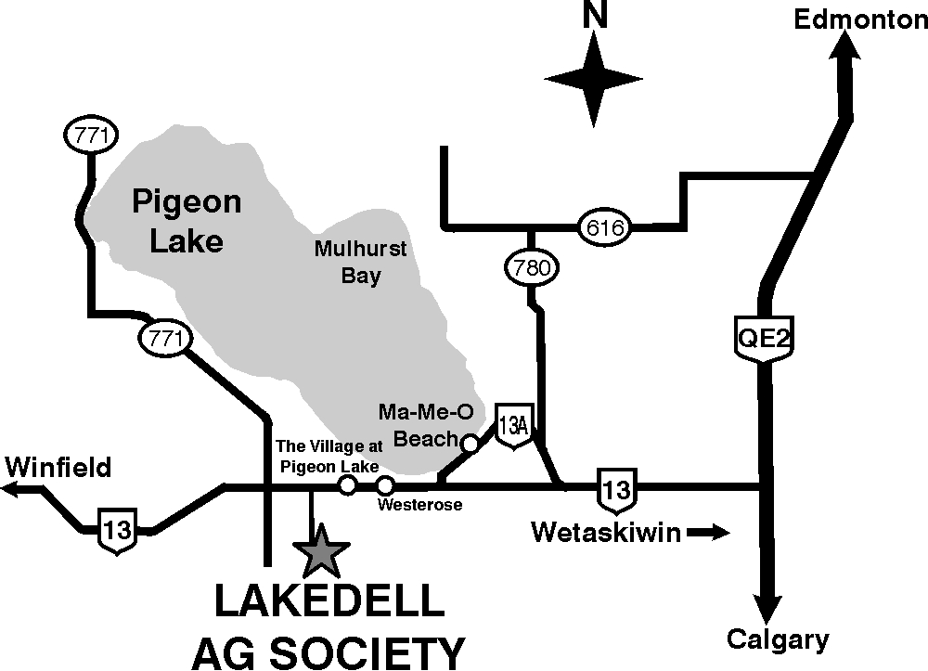

* **Lakedell Ag. Centre is located just south of Pigeon Lake.**
* **QE 2 South from Edmonton or North from Red Deer to the Hwy 13 exit (Ma-Me-o Beach).**
* **Drive approximately 29 kms (16 miles) West on Hwy 13, past the Village at Pigeon Lake to Range Road 12 (Lakedell School is on the north side of Hwy 13). Then drive South 1.5 kms (1/2 mile) on RR 12.**



**Emersyn Tabler – Grade 4**

**Falun School**

**See you on September 2nd!**